Name: Date:
Earth Science: Period:

Climate Factor: Latitude

- The map below shows the major climate zones on Earth
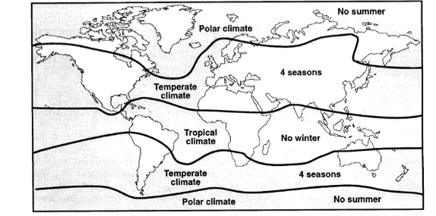
The primary factor controlling these climate zones is
- elevation c. latitude
- solar time d. longitude

- Which single factor generally has the greatest effect on the climate of an area on the Earth’s surface?
  - the distance from the Equator
  - the extent of vegetative cover
  - the degrees of longitude
  - the month of the year

- On the grid below, draw a line to show the relationship between latitude and average surface temperature.
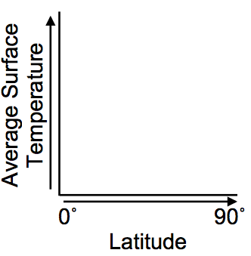

- Air temperature will rise slightly faster in Florida than in New York State because Florida
  - has a lower angle of insolation
  - has a higher angle of insolation
  - is closer to the Prime Meridian
  - is farther from the Prime Meridian
- The table below compares the average daily temperatures during the month of July in two cities. Both cities are along the Atlantic Ocean. Baltimore, Maryland is in the Northern Hemisphere, and Buenos Aires, Argentina, is in the Southern Hemisphere.
Which statement best explains why Baltimore is warmer in July?
  - Ocean waves keep Baltimore warmer in July.
  - There are fewer hours of daylight in Baltimore in July.
  - The Northern Hemisphere is tilted toward the Sun in July.
  - The Southern Hemisphere is tilted toward the Sun in July.

- The graph below shows the average monthly temperature of two cities, A and B.
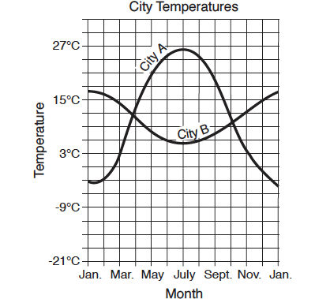
The temperature in city B is highest in January and lowest in July because city B is located
  - on the side of a mountain c. in the Southern Hemisphere
  - on an island d. at the North Pole

- On which shaded region of the map do the shaded land areas represent regions where the average annual temperature is greater than 18˚C (64.4˚F)?
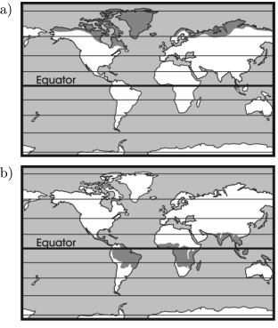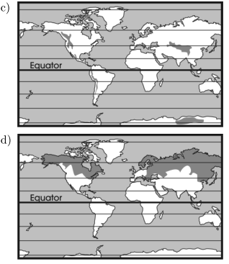
Base your answers to questions 8 and 9 on the map below, which shows one method of classifying Earth’s surface into latitudinal climate belts. In the tropical climate belt, the average monthly temperatures never drop below 18˚. In the polar climate belts, the average monthly temperatures never rise above 10˚C. The isotherms show the average monthly temperature of the coolest and warmest months. Effects of elevation have been omitted.
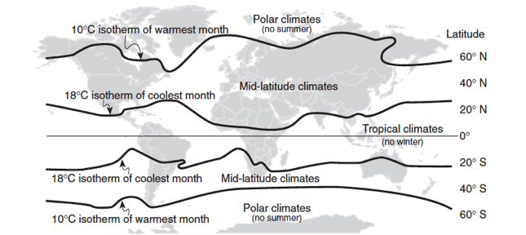

- According to the isotherms on the map, locations in the mid-latitude climate belts have average monthly temperatures between what values?

- Describe a specific characteristic of insolation received in the tropical climate belt region that causes the average monthly temperature to remain warm all year.

- The graph below shows the average monthly temperatures at cities A, B, C, and D. The latitude of each city is indicated.
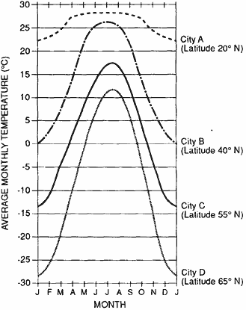
Describe the relationship between latitude and the annual temperature range of a location.

- The graph below shows the average monthly temperatures for one of the numbered areas on the map.
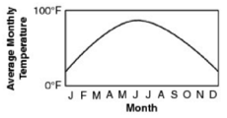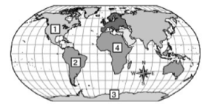

Which city on the map most likely has an average monthly temperature represented by this graph? Explain your answer.

Base your answers to questions 12 through 15 on the climate graphs below, which show average monthly precipitation and temperatures at four cities, A, B, C, and D.

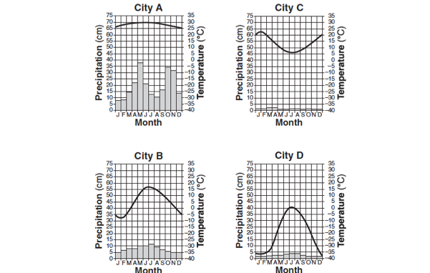

- City A has very little variation in temperature during the year because city A is located
- on the dry side of a mountain
- on the wet side of a mountain
- near the center of a large landmass
- near the equator

- During which season does city B usually experience the month with the highest average precipitation?
- spring c. fall
- summer d. winter

- It can be concluded that city C is located in the Southern Hemisphere because city C has
- small amounts of precipitation throughout the year
- large amounts of precipitation throughout the year
- its warmest temperatures in January and February
- its warmest temperatures in July and August

- Very little water will infiltrate the soil around city D because the region usually has
- a frozen surface c. a small amount of runoff
- nearly flat surfaces d. permeable soil

- The map below shows the average dates for the first autumn freeze in Mississippi.
Explain why there is such a large difference in the date of the first autumn freeze throughout Mississippi.

- The map shows the length of the growing season in New York State, expressed in days. The growing season is the average number of days between the last frost in the spring and the first frost in the fall. The graph line shows the relationship between the latitudes of Riverhead, New York; Albany, New York; and Massena, New York; and the length of the growing season at these three locations.
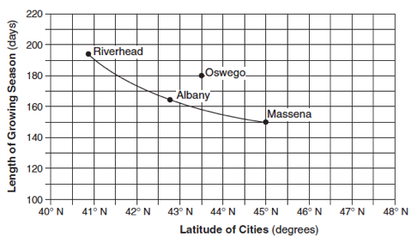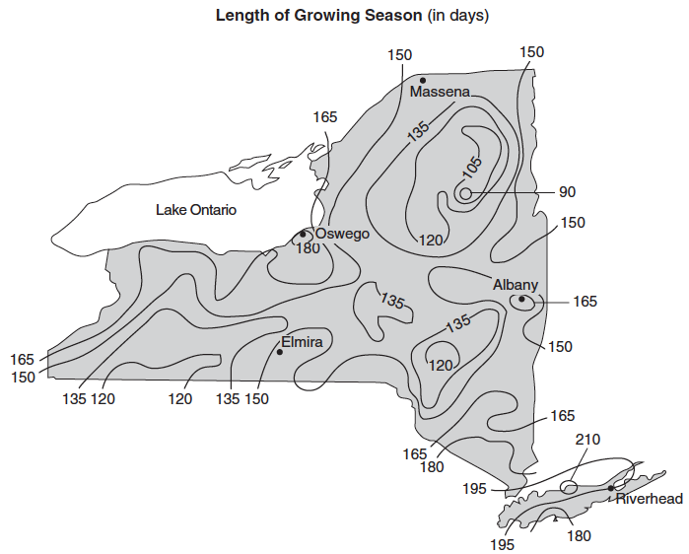

For Riverhead, Albany, and Massena, state the relationship between latitude and the length of the growing season shown by the graph.

